|  |  |  |  |
| --- | --- | --- | --- |
| **Author Name** | **Date** | **Execution Type** | **Platform** |
| Sanjay | 07/16/2020 | Regression | iPad |

**Pop-up/Banner:**

|  |  |
| --- | --- |
| **Banner Seen** | No |
| **Learn More - Redirection** | No |

**Social Media Links:**

|  |  |  |  |  |  |
| --- | --- | --- | --- | --- | --- |
|  | [**Facebook**](https://www.facebook.com/softvisionusa) | [**Instagram**](https://www.instagram.com/softvisionteam/) | [**Twitter**](https://twitter.com/softvision_usa) | [**LinkedIn**](https://www.linkedin.com/company/softvision) | [**YouTube**](https://www.youtube.com/user/SoftVisionTeam) |
| **Footer** | Yes | Yes | Yes | Yes | Yes |

**Note:** Mark ***‘Yes’*** if the links are working and ***‘No’*** if not inside the respective cells

**Web Pages QA Summary:**

|  |  |  |  |  |
| --- | --- | --- | --- | --- |
| **Page_ID** | **Page_Group_Level** | **Page_Name and URL** | **QA Status** | **Issue Reference** |
| 1 | Level 1 | [Home](https://www.cognizantsoftvision.com/) | FAIL | DEF-23 |
| 2 | Level 1 | [Join our Team - Careers](https://www.cognizantsoftvision.com/careers/) | FAIL | DEF-1, DEF-2, DEF-3, DEF-4, DEF-5, DEF-6 |
| 3 | Level 1 | [Contact +Form](https://www.cognizantsoftvision.com/contact/) | FAIL | DEF-7 |
| 4 | Level 1 | [About Us](https://www.cognizantsoftvision.com/about-us/) | FAIL | DEF-8 |
| 5 | Level 1 | [Privacy Policy](https://www.cognizantsoftvision.com/privacy-policy/) | PASS |  |
| 6 | Level 1 | [Softvision Suite](https://www.cognizantsoftvision.com/softvision-suite/) | FAIL | DEF-9 |
| 7 | Level 1 | [Our Portfolio](https://www.cognizantsoftvision.com/insights/guilds/client-stories/) | PASS |  |
| 8 | Level 1 | [What we do](https://www.cognizantsoftvision.com/services/) | FAIL | DEF-10 |
| 9 | Level 1 | [Our Thoughts](https://www.cognizantsoftvision.com/insights/) | FAIL | DEF-11, DEF-12, DEF-13 |
| 10 | Level 1 | [News](https://www.cognizantsoftvision.com/news/) | PASS |  |
| 11 | TBD | [Virtual Pods](https://www.cognizantsoftvision.com/virtual-pods/) | FAIL | DEF-14, DEF |
| 12 | TBD | [Game of Pods](https://www.cognizantsoftvision.com/game-of-pods/) | FAIL | DEF |
| 13 | Level 2 | [Insights Article](https://www.cognizantsoftvision.com/insights/) | PASS |  |
| 14 | Level 2 | [HWW_Guilds](https://www.cognizantsoftvision.com/guilds/) | FAIL | DEF-15,DEF |
| 15 | Level 2 | [HWW_Pods](https://www.cognizantsoftvision.com/pods/) | FAIL | DEF |
| 16 | Level 2 | [HWW_Our Approach](https://www.cognizantsoftvision.com/our-approach/) | FAIL | DEF |
| 17 | Level 2 | [HWW_Studios](https://www.cognizantsoftvision.com/our-studios/) | FAIL | DEF-14, DEF-15, DEF-22 |
| 18 | Level 2 | [Join our Team - Trainings](https://www.cognizantsoftvision.com/trainings/) | PASS |  |
| 19 | Level 2 | [Join our Team - Women at CSV](https://www.cognizantsoftvision.com/women-at-cognizant-softvision/) | FAIL | DEF |
| 20 | Level 2 | [Contact_Austin](https://www.cognizantsoftvision.com/studios/austin/) | FAIL | DEF-16 |
| 21 | Level 2 | [Contact_Las vegas](https://www.cognizantsoftvision.com/studios/las-vegas/) | FAIL | DEF |
| 22 | Level 2 | [Contact_Buenos Aires](https://www.cognizantsoftvision.com/studios/buenos-aires/) | FAIL | DEF |
| 23 | Level 2 | [Contact_Mysore](https://www.cognizantsoftvision.com/studios/mysore/) | FAIL | DEF |
| 24 | Level 2 | [Contact_Melbourne](https://www.cognizantsoftvision.com/studios/melbourne/) | FAIL | DEF |
| 25 | Level 2 | [Contact_Baia Mare](https://www.cognizantsoftvision.com/studios/baia-mare/) | FAIL | DEF |
| 26 | Level 2 | [Contact_L’viv](https://www.cognizantsoftvision.com/studios/lviv/) | FAIL | DEF |
| 27 | Level 2 | [Leadership](https://www.cognizantsoftvision.com/leadership/) | FAIL | DEF-17 |
| 30 | Level 2 | [SVS_ Page&square](https://www.cognizantsoftvision.com/page-square-inch-analysis-page/) | FAIL | DEF |
| 31 | Level 2 | [SVS_Inventory](https://www.cognizantsoftvision.com/inventory-planning-replenishment-page/) | FAIL | DEF-14, DEF-15 |
| 32 | Level 2 | [SVS_Demand](https://www.cognizantsoftvision.com/demand-planning-forecasting-page/) | FAIL | DEF-18, DEF |
| 33 | Level 2 | [SVS_Purchasing](https://www.cognizantsoftvision.com/purchasing-page/) | FAIL | DEF |
| 34 | Level 2 | [SVS_Assortment](https://www.cognizantsoftvision.com/assortment-planning-page/) | FAIL | DEF-16, DEF-18 |
| 35 | Level 3 | [Guilds_DevOps](https://www.cognizantsoftvision.com/guilds-list/cloud-and-dev-ops/) | PASS |  |
| 36 | Level 3 | [Guilds_Web](https://www.cognizantsoftvision.com/guilds-list/web/) | FAIL | DEF |
| 37 | Level 3 | [Guilds_Enterprise_Software](https://www.cognizantsoftvision.com/guilds-list/enterprise-software/) | FAIL | DEF |
| 38 | Level 3 | [Guilds_Quality_Engineering](https://www.cognizantsoftvision.com/quality-engineering/) | FAIL | DEF-19 |
| 39 | Level 3 | [Guilds_Mobile](https://www.cognizantsoftvision.com/guilds-list/mobile-2/) | PASS |  |
| 40 | Level 3 | [Author Page](https://www.cognizantsoftvision.com/author/andres-angelani/)* | PASS |  |
| 41 | Level 3 | [Job result](https://www.cognizantsoftvision.com/careers/positions/location/all-locations/guild/all-guilds/) | FAIL | DEF-5, DEF-14 |
| 42 | Level 4 | [Job detail page](https://www.cognizantsoftvision.com/mobile-guild/ios-developer/8776/)* | FAIL | DEF-20, DEF-21 |
| 43 | TBD | [Candidate Privacy Policy](https://www.cognizantsoftvision.com/candidate-privacy-notice/) | PASS |  |
| 44 | TBD | [Error Page](https://www.cognizantsoftvision.com/hm) | PASS |  |

*Indicates Sample page since there are multiple pages of same kind.

# DEF-1 | Join our Team-Careers | Overlapped Numbering

**Description:** On careers Our Openings section, the numbering is found overlapped.

**Steps to reproduce:**

1. Go to <https://www.cognizantsoftvision.com/careers/>
2. Click on any link in **Our Openings** section.
3. Click on **PROCEED** on **Candidate Privacy Notice.**
4. The first numbering seen in the pageis seen hidden.

**Expected:** The numbering has to come right beside Description.

**Actual:** The first numbering is overlapped.

**Reference:**

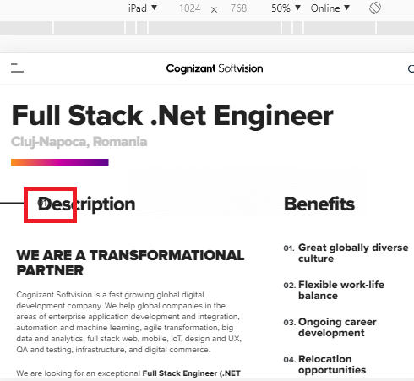

**Note:** Same issue is also observed in all the links present in **Our Openings** sections.

# DEF-2 | Join our Team-Careers | YouTube video volume not present

**Description:** The volume button is not present when YouTube video is played in the page and hence no volume when played.

**Steps to reproduce:**

1. Go to <https://www.cognizantsoftvision.com/careers/>
2. The volume button is not present when YouTube video is played in the page.

**Note:**  All the You Tube videos present in the page doesn’t have volume button and no audio.

**Expected:** The volume button should be present to adjust the volume.

**Actual:** The volume button itself is not present, hence there is no volume when played the YouTube video.

**Reference:**

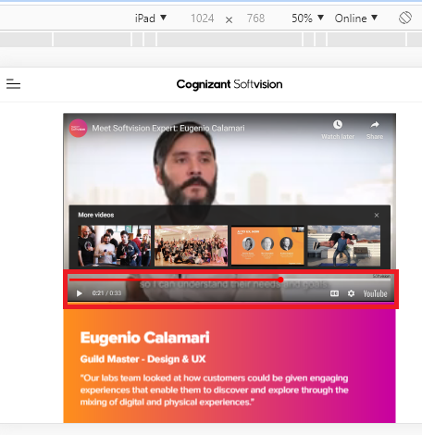

# DEF-3 | Join our Team-Careers | Link is not redirecting

**Description:** On LCA Notices pdf the link are not redirecting to its respective page

**Steps to reproduce:**

1. Go to<https://www.cognizantsoftvision.com/lca-notices/>
2. Click on any link
3. observe

**Expected:** Clicking on any link should navigate to its respective page

**Actual:** Clicking on any link is not navigating to its respective page

**Reference:**

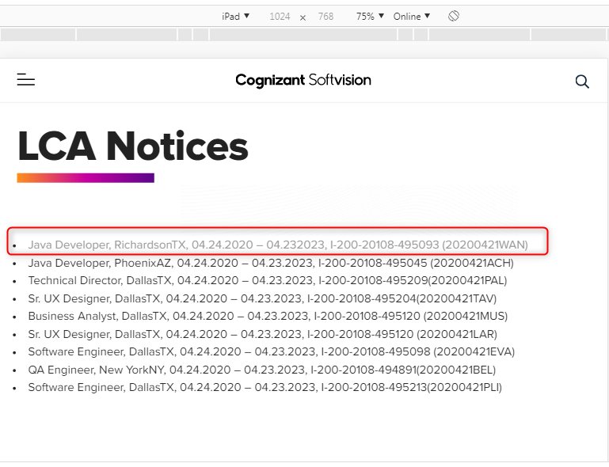

# DEF-4 | Join our Team-Careers | Extension of the file format not seen

**Description:** When tried to apply for a particular job profile without a resume the file extension is not seen completely

**Steps to reproduce:**

1. Click on <https://www.cognizantsoftvision.com/enterprise-software-guild/full-stack-net-engineer/2622/>
2. Click on proceed
3. Scroll down and Apply
4. Fill the form without resume attached
5. Check on “I‘m not a Robot”
6. And observe below upload resume button

**Expected:** Extension of the file format should be seen completely

**Actual:** Extension of the file format not seen completely

**Note:** Observe in all available Jobs

**Reference:**

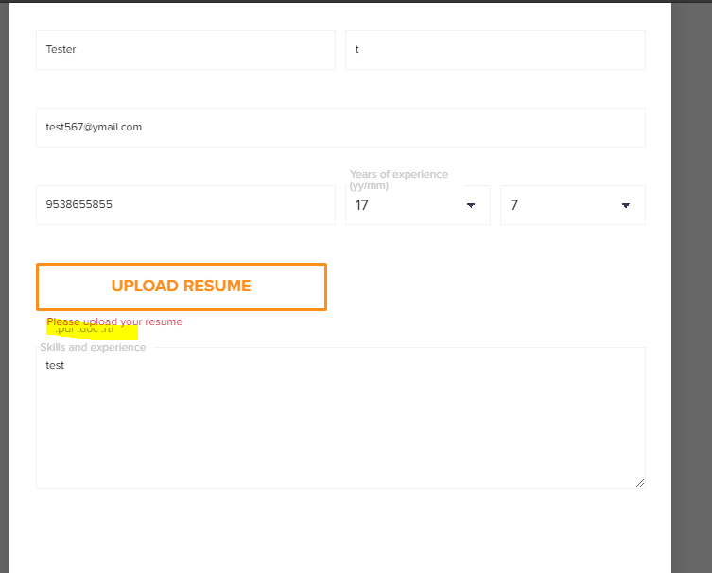

# DEF-5 | Career | Discrepancy observed after footer

**Description**: If we search for Bangalore location we must get only Bangalore location but we are getting Mysore in the title which leads to confusion

**Steps to reproduce:**

1. Go to <https://www.cognizantsoftvision.com/careers/positions/location/bangalore/guild/all-guilds/> (Career page)
2. Select Studios/Location as Bangalore
3. Check the result

**Expected:**  Vacancies in Bangalore Location should be shown as there was a filter only for Bangalore location

**Actual:** In title we have (Mysore) but filter applied is only for Bangalore location which leads to confusion

**Reference:**

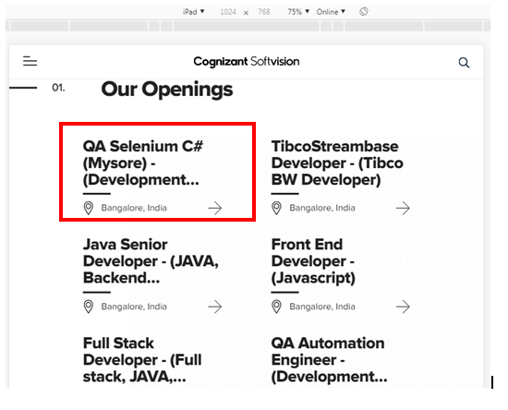

**Note:** Same issue observed on [Job result](https://www.cognizantsoftvision.com/careers/positions/location/all-locations/guild/all-guilds/)

# DEF-6 | Careers | “I‘m not a robot” is inconsistent

**Description: T**o check the check box of “I‘m not a robot” it behaves inconsistent and “ I am not a robot” captcha questions are not asked on iPhone

**Steps to reproduce:**

1. Click on <https://www.cognizantsoftvision.com/enterprise-software-guild/full-stack-net-engineer/2622/>
2. Click on proceed
3. Scroll down and Apply
4. Fill the form without resume attached
5. Check on “I‘m not a robot”
6. And observe

**Expected:** **T**o check the check box of “I‘m not a robot” it should allow with the captcha questions

**Actual: T**o check the check box of “I‘m not a robot” it might or might not allow and the captcha questions are not asked

**Reference:**

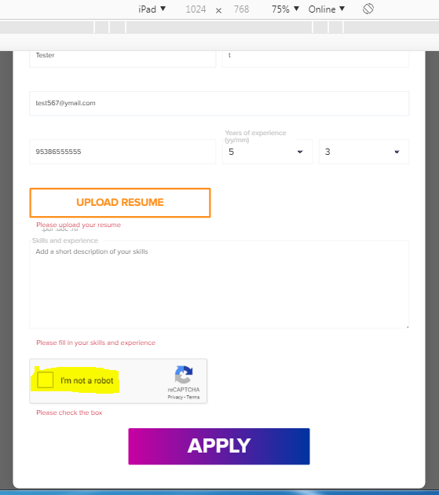

# DEF-7 | [Contact +Form](https://www.cognizantsoftvision.com/contact/) | Without attachment form can be submitted

**Description:** Without attachment, form can be submitted in contact page

**Steps to reproduce:**

1. Go to <https://www.cognizantsoftvision.com/contact/>
2. Fill the form by selecting “Work with Us (Careers)”
3. Without adding attachment submit the form
4. We receive “Thanks for submitting the form”

**Expected:** Without attachment, Form should not be submitted

**Actual:** Without attachment, Form is submitted

**Reference:**

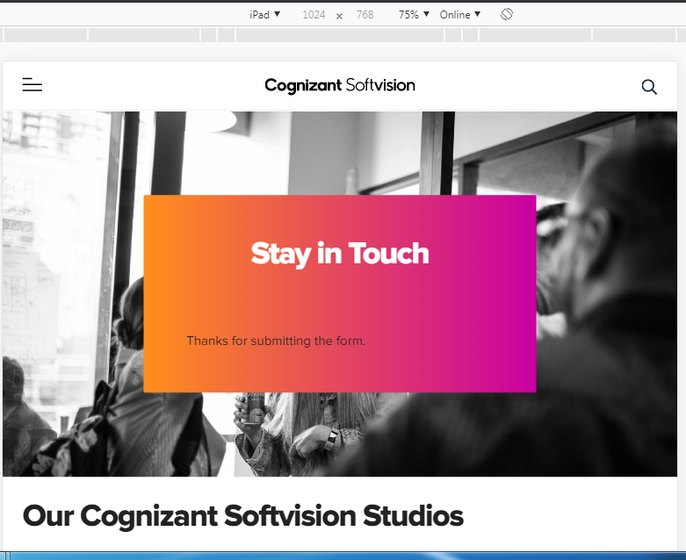

# DEF-8 | About us Page| Title overlap and text alignment

**Description:** Title is not clear and alignment is not as per design

**Steps to reproduce:**

1. Open [About Us](https://www.cognizantsoftvision.com/about-us/) page.
2. Observe the title and description.

**Expected:** Title must be clear and text alignment should be as per design.

**Actual:** Title overlapping and text alignment is not as per design.

**Reference:**

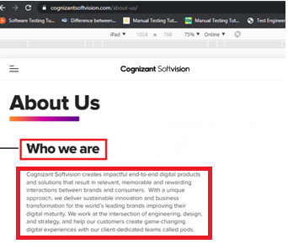

# DEF-9 | [Softvision](https://www.cognizantsoftvision.com/guilds-list/mobile-2/) Suite | “Request A Demo” Button is not working

**Description:** “Request A Demo” button is not functioning

**Steps to reproduce:**

1. Click on [Softvision Suite](https://www.cognizantsoftvision.com/softvision-suite/)
2. Scroll down
3. Click on “Request A Demo”
4. Observe

**Expected:** Button should work upon clicking it

**Actual:** Button is not working upon clicking it

**Reference:**

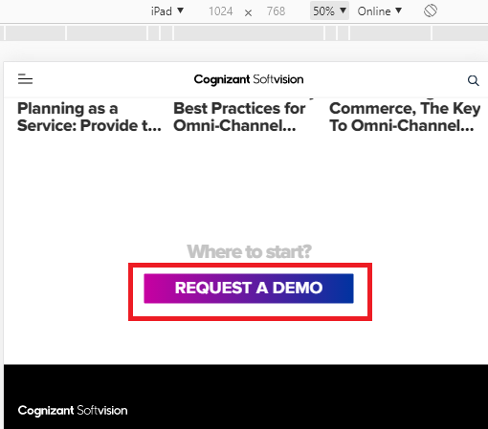

# DEF-10 | What we Do | YouTube video volume not present

**Description:** The volume button is not present when YouTube video is played in the page and hence no volume when played.

**Steps to reproduce:**

1. Go to<https://www.cognizantsoftvision.com/services/>
2. The volume button is not present when YouTube video is played in the page.

**Expected:** The volume button should be present to adjust the volume.

**Actual:** The volume button itself is not present, hence there is no volume when played the YouTube video.

**Reference:**

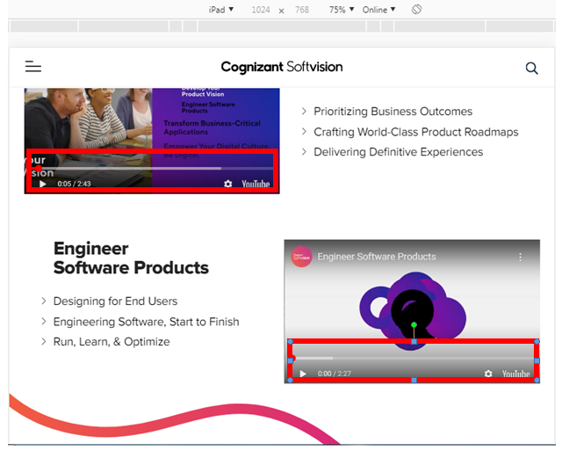

# DEF-11 | Our Thoughts| Tags not completely displayed

**Description:** All the tags that are selected should be displayed completely or at least when we hover the cursor full tag name should display

**Steps to reproduce:**

1. Open [Our Thoughts](https://www.cognizantsoftvision.com/insights/) page
2. Click on 4-5 options from drop down
3. Observe the titles of the tags selected

**Expected:** All the Tag names should display or at least on hovering the mouse on it

**Actual:** All the Tag names are not completely displaying and hovering the mouse on it has no effect

**Reference:**

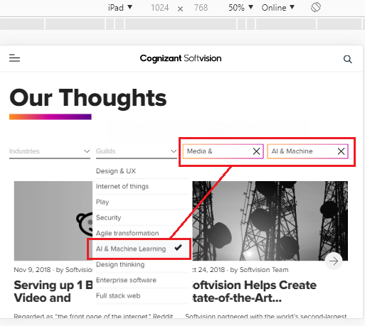

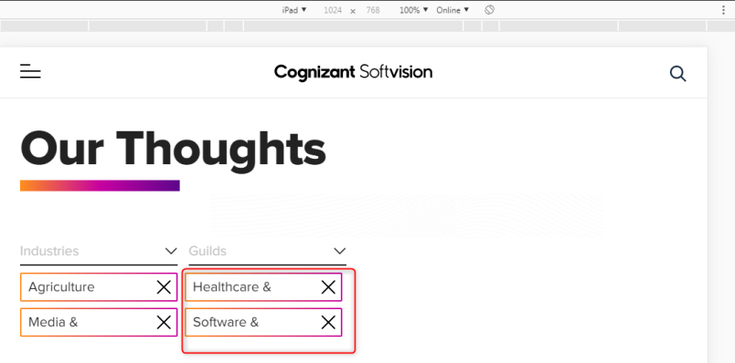

# DEF-12 | Our Thoughts | Heading is not aligned

**Description**: Heading is not completely seen and aligned

**Steps to reproduce:**

1. Click <https://marketing.softvision.com/transforming-while-performing?__hstc=61581043.ca07fa30b96e90ed0fd4163699012f44.1592906671054.1592906671054.1592906671054.1&__hssc=61581043.1.1592906671055&__hsfp=1229146266>
2. Observe

**Expected:** Heading should be completely seen and aligned as per the design

**Actual:** Heading is not completely seen and aligned

**Reference:**

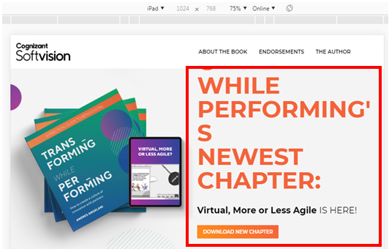

# DEF-13 | Our Thoughts| Discrepancy before and after applying filters

**Description**: First time when we land on Our Thoughts without applying filters we find “CHECK OUT OUR LATEST BOOK” then apply filter by checking any one option from the drop down, “CHECK OUT OUR LATEST BOOK” disappears.

Later remove all the filters and scroll even now we must get “CHECK OUT OUR LATEST BOOK” (I.e. before applying filter and after removing the filter it must match) but we don’t find it

**Steps to reproduce:**

1. Under “Our Thoughts” first time we find “CHECK OUT OUR LATEST BOOK”
2. With filter “CHECK OUT OUR LATEST BOOK” disappears
3. Now remove filter and observe
4. “CHECK OUT OUR LATEST BOOK” should display

**Expected:**  The design before applying filter and after removing the filter it must match

**Actual:** The design before applying filter and after removing the filter is not matching

**Reference:**

After removing the filters applied

**Note:** Observe with adding filters and also removing the filters.

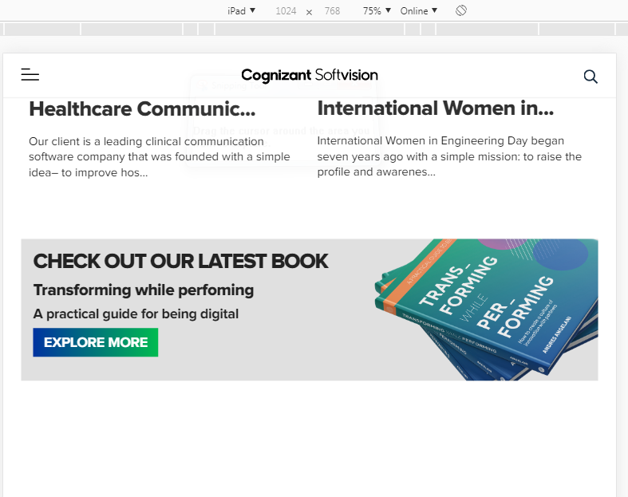

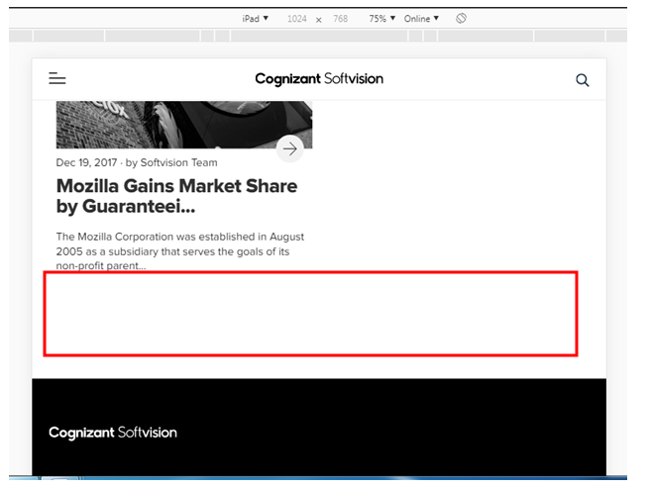

# DEF-14 | Virtual-Pods | Button is not working

**Description**: “Get in Touch” button is not functioning

**Steps to reproduce:**

1. Go to <https://www.cognizantsoftvision.com/virtual-pods/>
2. Scroll down completely
3. Click and Observe “GET IN TOUCH” button

**Expected:**  Button should open its respective page

**Actual:** Button is not Opening its respective page

**Reference:**

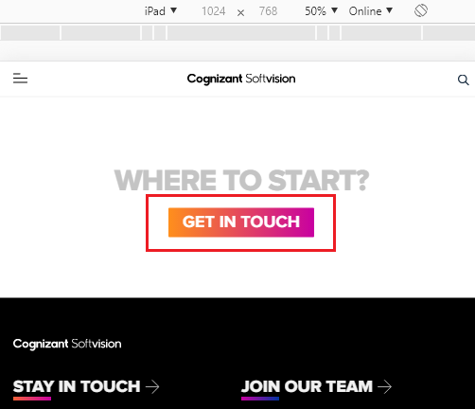

**Note:** Same issue is also observed on[HWW_Studios](https://www.cognizantsoftvision.com/our-studios/)**,** [HWW_Guilds](https://www.cognizantsoftvision.com/guilds/)**,** [SVS_ Page&square](https://www.cognizantsoftvision.com/page-square-inch-analysis-page/)**,** [SVS_Inventory](https://www.cognizantsoftvision.com/inventory-planning-replenishment-page/) and [Job result](https://www.cognizantsoftvision.com/careers/positions/location/all-locations/guild/all-guilds/)

# DEF-15| HWW-Guilds | YouTube video volume not present and sound not audible when played

**Description:** The volume button is not present when YouTube video is played in the page and hence no volume when played.

**Steps to reproduce:**

1. Go to<https://www.cognizantsoftvision.com/guilds/>
2. The volume button is not present when YouTube video is played in the page.

**Expected:** The volume button should be present to adjust the volume.

**Actual:** The volume button itself is not present, hence there is no volume when played the YouTube video.

**Reference:**

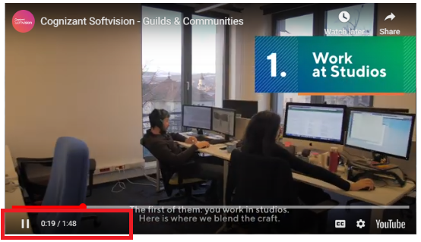

**Note: Same issue is also observed on** [HWW_Pods](https://www.cognizantsoftvision.com/pods/)**,** [HWW_Studios](https://www.cognizantsoftvision.com/our-studios/)**,** [Join ourTeam - Women at CSV](https://www.cognizantsoftvision.com/women-at-cognizant-softvision/)**,** [HWW_Our Approach](https://www.cognizantsoftvision.com/our-approach/)**,** [Virtual Pods](https://www.cognizantsoftvision.com/virtual-pods/)**,**  [SVS_Inventory](https://www.cognizantsoftvision.com/inventory-planning-replenishment-page/)**,**  [Guilds_Web](https://www.cognizantsoftvision.com/guilds-list/web/) and [Guilds_Enterprise_Software](https://www.cognizantsoftvision.com/guilds-list/enterprise-software/)

# DEF-16 | Austin | Button is not working

**Description**: “Get in Touch” button is not functioning

**Steps to reproduce:**

1. Go to <https://www.cognizantsoftvision.com/studios/austin/>
2. Scroll down completely
3. Click and Observe “Get in Touch” button

**Expected:**  Button should open its respective page

**Actual:** Button is not Opening its respective page

**Reference:**

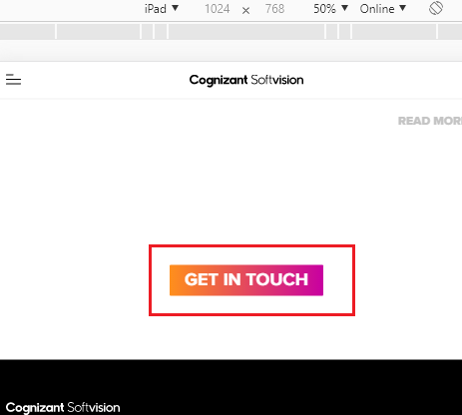

**Note: Same issue is also observed on** [Contact_Las vegas](https://www.cognizantsoftvision.com/studios/las-vegas/)**,** [Contact_Buenos Aires](https://www.cognizantsoftvision.com/studios/buenos-aires/)**,** [Contact_Mysore](https://www.cognizantsoftvision.com/studios/mysore/)**,** [Contact_Melbourne](https://www.cognizantsoftvision.com/studios/melbourne/)**,** [Contact_Baia Mare](https://www.cognizantsoftvision.com/studios/baia-mare/)**,** [Contact_L’viv](https://www.cognizantsoftvision.com/studios/lviv/)**,** [SVS_Demand](https://www.cognizantsoftvision.com/demand-planning-forecasting-page/)**,** [SVS_Purchasing](https://www.cognizantsoftvision.com/purchasing-page/) and [SVS_Assortment](https://www.cognizantsoftvision.com/assortment-planning-page/)

# DEF-17 | Leadership| Link is not redirecting

**Description:** On Leadership the links are not redirecting to its respective page

**Steps to reproduce:**

1. Go to <https://www.cognizantsoftvision.com/leadership/>
2. Click on **Tom Delbrook** link
3. Observe

**Note:** Same issue is also observed on **Snjezana Cvoro-Begovic**, **Girish Karunakaran**, **Ines Casares**, **Mihai Constandis**, **Raul Rodila** and **David Bolcsfoldi**

**Expected:** Clicking on **Tom Delbrook** link should navigate to its respective page

**Actual:** Clicking on **Tom Delbrook** link is not navigating to its respective page

**Reference:**

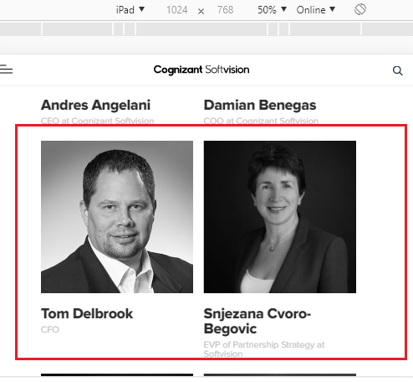

# DEF-18 | SVS Demand| Tag not completely displayed

**Description:** The tag should be displayed completely.

**Steps to reproduce:**

1. Open [SVS_Demand](https://www.cognizantsoftvision.com/demand-planning-forecasting-page/) page
2. Click on **Automating Forecasting** under section 01-**What you can achieve with it.**
3. Observe the title of the tag selected

**Expected:** Tag name should display completely

**Actual:** Tag name is not completely displaying

**Reference:**

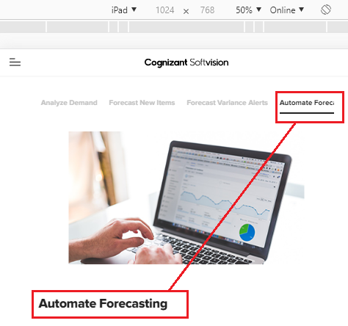

**Note:** Same issue is also observed on [SVS_Assortment](https://www.cognizantsoftvision.com/assortment-planning-page/)

# DEF-19 | Guilds Quality Engineering | Video is not being played

**Description**: In the engineering design inside “Quality Engineering” link video can’t be played

**Steps to reproduce:**

1. Click on [Guilds_Quality_Engineering](https://www.cognizantsoftvision.com/quality-engineering/)
2. Try playing the video on the **Quality Engineering** page

**Expected:** Video played on any page must play

**Actual:** Video in the **Quality Engineering** page is not playing

**Reference:**

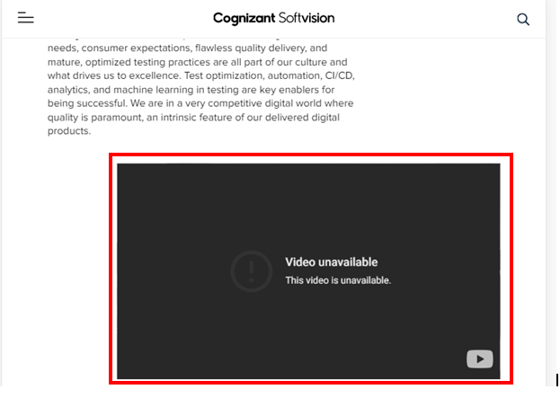

# DEF-20 | Job detail page* | Overlapped Numbering and No title is present

**Description:** The numbering is found overlapped, No title is present for the page.

**Steps to reproduce:**

1. Go to [Job detail page](https://www.cognizantsoftvision.com/mobile-guild/ios-developer/8776/)*
2. Observe the page title
3. Observe the numbering and Description title
4. The first numbering is seen hidden in the page.

**Expected:** The numbering has to come right beside Description.

**Actual:** The first numbering is overlapped.

**Reference:**

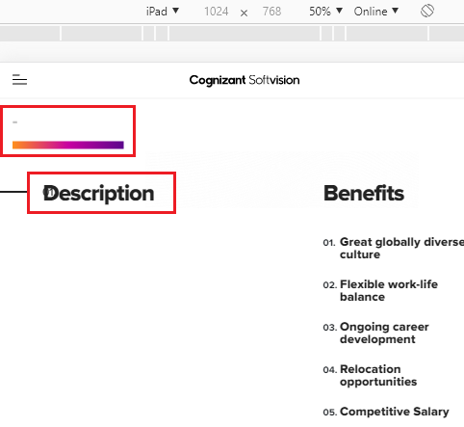

# DEF-21 | Job detail page* | Button is not redirecting

**Description**: “Get in Touch” button is not functioning

**Steps to reproduce:**

1. Go to <https://www.cognizantsoftvision.com/mobile-guild/ios-developer/8776/>
2. Scroll down completely
3. Click and Observe “Apply” button

**Expected:**  Button should open its respective page

**Actual:** Button is not Opening its respective page

**Reference:**

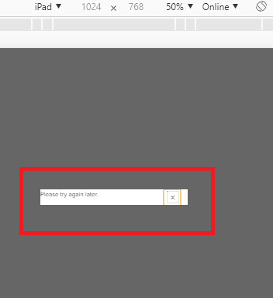

# DEF-22 | HWW Studios | Curve missing

**Description**: Wave curve is expected in the highlighted area

**Steps to reproduce:**

1. Click on [HWW_Studios](https://www.cognizantsoftvision.com/our-studios/)
2. Scroll and observe

**Expected:**  On [HWW_Studios](https://www.cognizantsoftvision.com/our-studios/) page a wave curve is expected in the highlighted area

**Actual:** On [HWW_Studios](https://www.cognizantsoftvision.com/our-studios/) page a wave curve is not displayed on highlighted area

**Reference:**

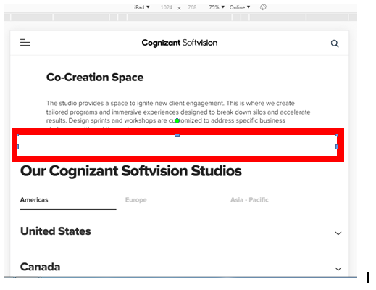

# DEF-23 | Home | Volume control button fails

**Description**: In Home Page sound button is not working video plays with no sound

**Steps to reproduce:**

1. Go to <https://www.cognizantsoftvision.com/>
2. Click on Mute /Unmute button
3. Observe

**Expected:**  Video should have sound when clicked on Sound button.

**Actual:** There is no sound when clicked on Sound button.

**Reference:**

